Differentiation and the Severity of Terrorist Attacks

Justin Conrad & Kevin Greene
University of North Carolina at Charlotte

Abstract
A wide range of literature on ethnic conflict and terrorism has argued that domestic competition increases the likelihood that a political organization will use violence in an effort to distinguish itself. Known as “outbidding,” empirical evidence for such a phenomenon has thus far been limited. The bulk of the empirical analysis, however, has focused on the effect of domestic competition on the quantity of violence. This study instead argues that competition should have an observable effect on the quality of violence, as organizations seek to differentiate their brand from others. Using information about the tactics and targets of all terrorist attacks from 1970-2010, the results suggest that an increase in the competitiveness of a political market leads to more severe or “shocking” types of attacks.

When explaining the behavior of terrorist organizations, scholars frequently cite a strategy of “outbidding” as a motivating factor in the decision to launch attacks. When a terrorist organization experiences an increase in domestic political competition, they may respond by increasing their level of violence in order to “outbid” their competition in garnering public support (e.g., Crenshaw 1981; 1985; Oots 1989; Bloom 2005; Kydd and Walter 2006). Hamas, which used unprecedented levels of violence during the First Intifada in an effort to outbid other Palestinian groups, is often cited as the classic example of a terrorist organization engaging in such behavior. Despite the intuitiveness of this strategy, however, empirical tests of outbidding (e.g., Findley and Young 2012, Conrad 2013) have found limited support for the theory. This paper argues that previous literature has not fully examined the hypothetical implications of outbidding theory. Most of these studies only analyze the effect of competition on the quantity of violence used by terrorist organizations, while often overlooking that domestic competition should have a more discernable effect on the quality of violence. In particularly competitive environments, violent groups are incentivized to engage in more shocking or innovative tactics because it distinguishes their brand from competitors, ultimately making the organization less sensitive to other costs.
While previous treatments of outbidding have implicitly acknowledged the role of competition in the tactical choices of organizations, almost all have focused on a single tactic: suicide terrorism (e.g., Bloom 2005). Although limited evidence of a relationship between domestic competition and the use of suicide terrorism exists, we argue that suicide attacks are simply one of many tactical choices that an organization can make to distinguish itself. We therefore analyze how domestic political competition affects the likelihood of a wide range of attacks, based on target types and the methods used during the attack. All terrorist attacks are not created equal and some have a larger impact, either because of who is being targeted or the kind of attack that is carried out. Attacks on civilians, for instance, are far more shocking than attacks on rival political groups and bombings are more shocking than unarmed assaults. The nightmarish “human lawnmower” proposed by the former Al-Qaeda in Iraq, involved attaching moving blades to the front of a pickup truck and driving it through a crowded public place, providing anecdotal support that terrorist organizations in competitive marketplaces (such as Iraq during the height of the war there) have actively tried to launch more “shocking” attacks to distinguish themselves.
The wide variation in the severity of attacks and their anticipated psychological effects must be accounted for in order to properly test the logic of outbidding. To do this, we have categorized domestic terrorist attacks by their relative level of severity or “shock value.” We measure severity in two ways: the severity level based on the target type and the severity level of the methods used in the attack. The severity level therefore captures the likely impact of an act based on the identity of the victim, and how the attack was carried out.
In the following sections, we lay out how past studies have analyzed the relationship between domestic competition and terrorism, and then incorporate the economic concept of differentiation to explain how terrorist organizations may derive greater utility by using more extreme or shocking attacks. By applying the logic of traditional firms in competitive markets, we may be able to better understand why terrorist organizations might use different types of violence when faced with domestic competition. Analyzing patterns of violence at both the state and organization levels, the results of this study suggest that, on average, greater domestic political competition incentivizes organizations to increase the severity of their attacks.

Rationalism and Outbidding
Much of the literature examining the relationship between political competition and terrorism assumes that terrorist organizations are rational actors that select strategies and tactics offering them the highest expected utility. The very choice to engage in terrorism is thought to be indicative of a group which expects a lower utility from conventional tactics (e.g., Fromkin 1975; Crenshaw 2002; Lake 2002). While terrorism rarely seems to achieve the stated political goals of most organizations (Abrahms 2006; 2012), Lake (2002, p.17-9) notes that terrorism offers the hope of shifting the balance of power between the terrorist organization and the state, giving the organization better bargaining power in the future. The terrorists’ best chance of shifting the balance of power is by convincing more and more people in the target audience to join, or at least be sympathetic, to their cause (Kydd and Walter 2006). To that end, terrorist organizations allocate resources and make tactical choices in an effort to maximize their utility (Caplan p 94).
Organizational theories, including those focusing on terrorist groups, argue that political organizations must balance their strategic goals with the need to sustain the organization (Crenshaw 1985; 1987; Wilson 1995) Self-preservation, therefore, is a fundamental concern of all political organizations. Crenshaw (1985) notes that while terrorist organizations and their leaders, in particular, have long term goals, a primary focus of most organizations is survival. Since the membership size of terrorist organizations and the level of popular support they enjoy seem to be correlated with their longevity (Blomberg, Gaibulloev and Sandler 2011; Cronin 2006; Cronin 2009), increasing recruitment and/or public support may lead to greater chances of survival and, perhaps, greater chances of achieving long term strategic goals. In environments where there are multiple competing organizations, however, terrorist organizations must vie for access to the same resources (e.g., media attention, recruits, public support, etc.). Since competition directly and indirectly threatens the resource base necessary to sustain the organization and ensure its effectiveness, it follows that terrorist organizations should make tactical choices in an effort to increase their share of resources within a competitive environment.
The theory of outbidding (e.g., Bloom 2005) is based on such logic, arguing that terrorist organizations seek to gain the upper hand in media coverage, recruiting and public support when there are multiple competing parties. Bloom (2005, p. 95) argues that “where there are multiple groups, violence is a technique to gain credibility and win the public relation competition.” Further, outbidding is more likely when there is a greater number of actors competing for the same resource base (Bloom 2005). Outbidding is expected to occur, therefore, when two key conditions hold: two or more domestic parties are competing for the leadership role of a particular cause, and the general population is uncertain about which of the groups best represents their interests (Kydd and Walter 2006). With incomplete information, the public cannot be sure which group is the most committed to the cause. The public (from which recruits are also drawn) may view the organization as either “a strong and resolute defender of the cause (zealots) or weak and ineffective stooges of the enemy (sellouts)” (Kydd and Walter 2006, p.76). Chenoweth (2010) adds that increased competition creates conflict by default, even when two or more political organizations are ostensibly fighting for the same cause.
Even in non-violent political interactions, the public is likely to favor more extremist representatives, who are seen as providing a stronger bulwark against the opposing side (Canes-Wrone and Shotts 2007). Violence offers terrorist organizations a similar advantage by signaling that they are truly committed, rather than weak, actors. In particular, the literature on outbidding has focused largely on the phenomenon of suicide terrorism, with Bloom (2005) and others arguing that this particular tactic is a function of competitive political environments. The willingness of an organization to sacrifice one of its own members (not to mention the willingness of an individual to sacrifice herself) in order to further a cause seems to signal the deepest level of commitment.
Importantly for this study, the argument about how competition leads to suicide terrorism is an argument not about the frequency of violence, but rather the type of violence that is chosen. Especially in environments where groups are already using violence, the quality of violence may be the most effective way to distinguish themselves from competitors. Hamas’ use of suicide terrorism in the early 1990s was seen as a means of distinguishing itself from Fatah, which had already used more “traditional” types of terrorist attacks. In other words, Hamas likely would not derive much purchase from “more of the same,” but instead generated support by choosing a relatively innovative tactic. As Enders and Sandler (2006) note, changes in the costs and benefits “of one type of terrorist activity will cause the terrorist group to substitute” another activity which provides a greater expected utility. They cite the example of the installation of metal detectors at U.S. airports in the 1970s, which decreased the number of skyjackings, but may have led to an increase in alternative types of terrorist activities. From this perspective, if it becomes more costly to use a particular tactic, or if the benefits of that tactic are reduced, terrorist organizations should seek alternative tactics. And increased competition among terrorist organizations reduces the benefits derived from tactics that have already been used. In such environments, organizations should look to differentiate themselves with new and innovative tactics.

Differentiation of Terrorist Attacks
The logic of differentiation in traditional economic markets has been studied extensively and dates back to the 1930s (Chamberlin 1933; Robinson 1933; Smith 1956). Differentiation was traditionally thought of as the ability of a firm to charge a higher price for its product or make a larger profit (see Sharp and Dawes 2001). Sharp and Dawes (2001) argue that differentiation occurs (p.739) “when a firm/brand outperforms rival brands in the provision of a feature(s) such that it faces reduced sensitivity for other features.” Baker (1996), Mercer (1992), Dickson (1997) and Powers (1991) all note that firms differentiate their goods or services in order to achieve a reduced price sensitivity or garner a higher price. In other words, differentiation can be thought of as anything that allows a firm and/or its products to “stand out” in a given marketplace (Kotler et al 1996; Guiltinan and Paul 1991; Saunder, in Gower 1995). As a firm's products become more differentiated relative to competing products, the firm experiences reduced sensitivity to other factors. This reduced sensitivity, in turn, benefits a firm or organization by diminishing the level of direct competition and allowing the firm to capture a greater market share (Sharp and Dawes 2001). A classic example of successful brand differentiation is Procter & Gamble’s marketing of Folger’s instant coffee, which emphasized the product’s “flaked coffee crystals.” The marketing effectively implied to consumers that this feature improved the taste of the coffee (Carpenter, et. al. 1994). In reality “flaked coffee crystals” have no effect on the taste of instant coffee. Folgers had not created a new product to gain larger market share, they had simply convinced potential customers that Folgers coffee was different, and ultimately “better”. The success of the marketing campaign relied on the public’s perception of “flaked coffee crystals.” In the same way, when terrorist organizations use more severe attacks they rely on how the public perceives these attacks. While committing more severe attacks may not indicate greater strength or help the group achieve long term goals, the spectacle of more severe attacks might generate the perception that the organization is successful.
Differentiation of organizations, therefore, leads to a higher “premium” associated with their activities, and ultimately, a decreased sensitivity to other potential costs created by competition. While differentiating has generally been applied to economic markets, the same logic should apply to any organization trying to stand out in its respective “marketplace.” In this case the “firms” are terrorist organizations, whose “products” are the attacks they carry out. Much like traditional firms, terrorist organizations are forced to compete directly with other firms (non-violent or violent political groups). Also like traditional firms, terrorist organizations seek to control a larger market share and to overcome their competitors.
Terrorist organizations may expect to derive greater utility by focusing on a few high yield attacks rather than carrying out a large number of attacks with smaller impacts. It is reasonable to argue that combined, all of al Qaeda’s attacks prior to, and following 9/11, did not have the same impact as that single attack. By executing an innovative or shocking method of attack, or by attacking a high-profile target, terrorist organizations should be better able to distinguish themselves in a given marketplace, particularly with respect to their competitors. For terrorist organizations, more innovative and shocking tactics make the organization less sensitive to their lack of efficacy in achieving their strategic goals. Differentiation therefore allows an organization to steepen its demand curve, making it less sensitive to changes in supply.
The modified supply and demand curves in Figures 1 and 2 illustrate this relationship between a terrorist organization’s level of public support and the perception of the group’s chance of achieving their stated political goals. The x-axis in each figure represents the organization's level of public support, while the y-axis represents the public perception of the group’s probability of success. We argue that public support and recruitment (demand) will be less sensitive to a group’s achievement of its goals (supply) when a group successfully differentiates itself. The graphs are identical, except that the graph in Figure 2 has a steeper demand curve than the graph in Figure 1. The steepness of the demand curve is determined by elasticity of demand, or how sensitive one variable is to a change in another. In traditional economic studies, elasticity determines how responsive customers are to a change in price. In our model elasticity measures how sensitive a terrorist organization’s public support is to changes in the perception of their chances of success. The steeper demand curve for a differentiated organization indicates that it will experience a lower rate of decline in public support when its perceived chances of success fall, relative to an undifferentiated organization. This is represented by the large gap between s₁ and s₂ in Figure 1 and the smaller gap between s₁ and s₂ in Figure 2.
Figure 1 About Here

Figure 2 About Here

The use of more severe attacks may steepen the demand curve in a number of ways. The spectacle of more extreme attacks generates more attention and signals that a group is committed to achieving their goals, regardless of their actual level of success. Commentators have suggested that al-Shabaab was at its weakest in late 2013, when their spectacular attack against a Kenyan mall significantly raised their profile (see Young 2013). Groups that do not effectively differentiate themselves will have a more shallow demand curve. As a result, any perception that the group is weak or has a low chance of success has a greater influence on their ability to gain support and recruits (Sharp and Dawes 2001, p. 755). Additionally, the use of more extreme attacks can create barriers to entry for other terrorist organizations that are not willing or able to carry out these types of attacks. Aside from creating moral dilemmas for some organizations, the use of more extreme attacks might simply reduce the number of available substitutes. Because of the higher shock value of increasingly severe attacks, there may be less room for differentiation by default.
While it is entirely possible that the use of more extreme attacks may hurt an organization’s overall public image (Crenshaw 2007), differentiation still offers a useful tool to mask an organization’s failure to achieve their political goals. Importantly, it is more difficult to differentiate when there is a greater level of competition, because tactics can be copied (Sharp and Dawes 2001). This raises the incentive for each terrorist organization to devise some signature attack or innovative tactic that separates them from the other groups. Further, it is most efficient for an organization to differentiate on an aspect that is low cost to provide which results in decreased sensitivity to other costs (Sharp and Dawes 2001, p. 752). For terrorist organizations some of the most extreme attacks are also the most low cost to deliver, such as attacks against unprotected civilians and targets like shopping malls and restaurants. And we argue that such attacks are likely to lead to decreased sensitivity to the public perception of the group’s success, something that is much more difficult to deliver.
Among all political organizations, then, it can be argued that differentiation is most important to terrorist groups, precisely because they are unlikely to achieve their stated goals (Abrahms 2012). Differentiation may be the key to increasing recruitment, deterring defection and maintaining public support (Post, Sprinzak, and Denny 2003). If a terrorist organization is willing to use extreme attacks, it not only demonstrates greater commitment to a cause but may make recruits care less about the overall chances of success. A group that sufficiently differentiates itself from competitors might find that an event like a government crackdown on their operations or the death of a key leader – events that signal declining effectiveness - have less of an impact on their ability to garner support and recruits. A group with a steeper demand curve made possible through differentiation will take a smaller hit in terms of public opinion and recruitment relative to an undifferentiated group. In an unusually competitive market, this might be the edge that a terrorist organization needs to sustain itself or to build enough of a support base to overtake a competitor.

Suicide Terrorism as Differentiation
Studies that have explored the role of differentiation in terrorist decision-making have most often focused on a single category of attacks: suicide. Suicide attacks are viewed as one of, if not the most, extreme terrorist tactic. Conservative estimates suggest that suicide attacks kill four times as many people, on average, as non-suicide attacks (Atran 2003; Hoffman 2006). More importantly, compared to other types of attacks, suicide terrorism has a disproportionate psychological effect on the target audience (Hoffman 2004). Suicide attacks are therefore likely to garner more media attention and signal greater commitment on the part of the terrorist organization. Mia Bloom (2005) notes that, “historically we can observe that suicide terror was adopted when multiple organizations ramped up insurgent violence with increasing degrees of lethality. Where there are multiple groups, violence is a technique to gain credibility and win the public relation competition” (p.95). She also points out that in 2000 Hamas was the only Palestinian terror groups to use suicide attacks but that by 2002 many other Palestinian groups had begun to use the tactic. While Findley and Young (2012) point out that we may not be able to effectively draw conclusions from a single case such as Israel, it nonetheless provides some anecdotal evidence that increasing levels of competition may lead terrorist organizations to differentiate themselves by turning to more shocking and innovative tactics.
While the literature on terrorist competition has focused heavily on suicide terrorism, there are innumerable ways in which an organization might differentiate itself. Piazza (2007) notes that from 1968 to 2005 only 3.36% of the total number of domestic terrorist attacks were suicide attacks. If terrorist organizations do indeed seek to differentiate themselves in competitive environments, and if suicide terrorism is so uncommon, it follows that there must be other methods that organizations use to “stand out.” The same logic underpinning outbidding theories should also drive the use of higher “shock value” attacks and targets.

The Quality of Violence
Much has been made about the possibility for public “backlash” against terrorist organizations when they become too violent (e.g., Crenshaw 1991; Cronin 2009) and that violence may actually be counterproductive compared to non-violent campaigns (Chenoweth and Stephan 2011). Abrahms (2008; 2012) specifically finds that terrorist groups that use violence against citizens are unlikely to achieve their stated political goals. The implication of this literature is that the choice to engage in more severe attacks may not assist the organization in achieving its long-term goals. But the fact that organizations continue to engage in shocking displays of violence suggests that, under some conditions, organizations still expect that the benefits of such attacks outweigh the potential long-term costs associated with public backlash and adversary intransigence. We argue that a focus on short-term gains and organizational survival, both of which are likely in an increasingly competitive marketplace, creates conditions under which more severe violence offers greater expected utility to terrorist organizations.
One important way in which terrorist organizations may derive immediate, tangible benefits from the use of such violence, is the media coverage it typically generates. There is a variety of literature investigating how the types and targets of terrorist attacks influence the amount of coverage they receive. Since most terrorist attacks receive no media coverage (Weimann and Winn 1994, Chermak and Grunewald 2006, Paletz et al. (YEAR)) there is an incentive for terrorists to pull off attacks that are particularly likely to be covered, by which they may influence a wider audience. Scott (2001) notes that, “to compete successfully for media attention, terrorists must be original enough to stage incidents that are a departure from past events. Hence, large media returns to terrorism come mostly from the perpetrators’ imaginative abilities” (p. 126). This aligns with the logic of this paper, that terrorist organizations may receive at least short term benefits from the use of more innovative attack types and by attacking more “shocking” targets that will influence the media, and ultimately, the general public. Weimann and Winn (1994) find that attacks that cause harm to individuals are twice as likely to be covered as attacks that do not. Paletz et al. (1985) find that attacks that involve violence receive a greater amount of coverage compared to non-violent methods. Nacos (2003) finds that attacks that kill a large number of people or cause large amounts of destruction are likely to receive more media attention. Weimann and Winn (1994) and Delli Carpini and Williams (1987) find that kidnappings, hijacking, and hostage situations are the most likely to receive coverage and that attacks that result in death or injury are more likely to be covered. Chermak and Gruenewald (2006) note that a terrorist attack must pass an “emotional threshold” in order for the media to cover the event, and because homicide (especially one caused by a terrorist attack) is a relatively rare event, this is generally “newsworthy.” They also find that hijackings, incidents involving firearms, and bombings are more prominently covered. The identity of the victim also seems to matter, as Carpini and Williams (1987) find that the amount of coverage of attacks against members of the military and government fluctuate widely, while coverage of attacks against private citizens are consistently overcovered.
At face value, then, the original logic of outbidding seems quite intuitive: more armed groups creates an incentive to distinguish oneself. Despite this intuitiveness, past studies of outbidding (Findley and Young 2012; Conrad 2013) find little empirical support for the theory. Nemeth (2013) does find limited support for outbidding logic but notes that it may depend on the country's acceptance of violence. Nemeth also finds that left-wing organizations reduce their violence when faced with domestic pressure, while religious and nationalist groups carry out more attacks when faced with domestic competition.
These studies all share a common approach to measuring evidence of outbidding. Findley and Young (2012) analyze the effect of competition on the number of both suicide and non-suicide terrorist attacks that occur in a given year, both domestically and transnationally. Nemeth (2013) and Conrad (2013) examine the number of domestic and transnational attacks, respectively, that occur in a given year. In other words, all of these studies have analyzed the effect of terrorist competition on the quantity of terrorism. The logic of outbidding, and the points that we have made about differentiation, however, imply that simply increasing the amount of violence may not be the only (nor even a useful) way to distinguish an organization. Raw counts of the number of attacks, therefore, do not capture the fact that the quality of terrorist attacks (in terms of severity) varies widely. For this reason, we expect that evidence of differentiation may be more apparent when looking at who the terrorist organizations are targeting and the methods of attack that they use. Attacks against “soft targets” like the civilian population at the 2013 Boston Marathon better differentiate terrorists compared to attacks against government and military targets. Terrorists, therefore, consider the “shock value” of their attacks, and it is reasonable to believe that increasing “shock value” may be one way in which organizations can stand out in a crowded marketplace. By only looking at the quantity of attacks, or only analyzing one particular type of attack (suicide), previous literature has potentially missed significant evidence of the differentiation process.
Contrary to what Nemeth (2013) proposes, we posit that an environment of increased competition provides incentives for terrorist organizations to differentiate themselves from other terrorist groups. In an environment where multiple terrorist organizations are all committing terrorist attacks the utility of each additional attack will inevitably lead to diminishing returns in terms of differentiating the organization. In this situation it may become necessary to introduce a new “product” in order to capture a larger market share. Even in a situation of extreme freeriding, where only one terrorist organization carries out attacks and the other terrorist organizations commit no attacks and simply claim credit for the attacks, there still remains an incentive to innovate because even the free riders should receive diminishing returns from the additional attacks. This may also create an environment where the credibility of groups is questioned, because it is highly unlikely that multiple groups are responsible for the same attacks. This provides even further incentive to differentiate and create a brand that is harder to copy. If a terrorist organization is able to effectively differentiate, they will likely reap more utility from each attack.
This leads us to two testable hypotheses. The first of these is a test of the underlying logic of differentiation, that more competition will cause terrorist organizations to engage in more extreme forms of terrorism as the groups attempt to distinguish themselves from their competitors:
Hypothesis 1: States with more armed groups will experience more severe types of terrorist attacks than states with fewer groups.
The second hypothesis captures the logic of the preceding discussion, that more of the same type of terrorist attack provides diminishing returns, and therefore incentivizes organizations to engage in increasingly extreme tactics. As the quantity of attacks increases, the marginal utility of any one attack decreases, thus organizations may engage in attacks with higher “shock value” as a way to stand out in a market already oversaturated with violence:
Hypothesis 2: States that experience more terrorist attacks will experience more severe types of terrorist attacks than states that experience fewer terrorist attacks.
In the following sections, we describe how we plan to test our hypotheses, and then present results from our analysis of the effect of competition on the quality of violence.

Research Design
To improve our understanding of how organizations use violence to differentiate themselves, we propose a new set of ordinal measures capturing the severity level or “shock value” of terrorist attacks. We rely on the Global Terrorism Database, which maintains a wide range of information on all terrorist attacks from 1970 to 2010 (GTD 2011). We focus on two pieces of information about each attack that allow us to compare the relative severity level of the violence being employed at any given time: the type of target that the terrorists attacked, and their method of attack.
Target Severity GTD identifies 22 different categories of targets, from the type of individual (e.g., tourist) to the type of organization (e.g., media). Although the categories provided are nominal, to create our measure of severity, we grouped target types into three ordinal categories, based on the “shock value” or likelihood that the attack would be particularly noteworthy. The variable equals ‘1’ if the attack is against infrastructure targets, including telecommunications, transportation, airports, maritime infrastructure, food or water sources, and utilities. In each of these cases, the attack is against a non-human target even though some attacks may have implications for humans. We consider this to be the lowest level of target severity. While attacks that disrupt infrastructure and weaken the government’s ability to provide for its citizens may be strategically useful, we argue that these attacks are not as poignant as attacks aimed at citizens. Moving up in severity, we code an attack as a ‘2’ if it is against any of the following target types: police, military, government personnel, other terrorists or violent political parties. In each of these cases, the target represents either a type of combatant or potential rival to the terrorist organization, and captures attacks against individuals, rather than infrastructure. It can be argued that directly contesting the government is a greater show of strength for the organization, but overall, groups that use terrorism are not in a position to effectively change the government directly. It might be more effective in the short-run for groups to target relatively softer targets (citizens), which still serves to undermine the government’s credibility. At the highest level of severity, level ‘3,’ we include attacks against all civilians (non-governmental, non-combatants), including private citizens, tourists, educational personnel, non-governmental organizations (NGOs), private businesses and the media. Such targets are likely to be more “shocking” and therefore provide greater differentiation compared to infrastructure and government/combatant targets. Finally, all attacks listed as “Other” in the GTD data are coded as missing.
Attack Type The second way in which we categorize the severity level of attacks is by the method of attack itself. In this case, GTD categorizes the tactic used in the attack by classifying it as one of nine types of attacks. Once we again, we collapse the nominal categories into an ordinal scale in which the lowest value (‘1’), indicates attacks in which human beings are not in dire physical danger. These include attacks against infrastructure and unarmed assaults. These attacks are all characterized by low levels of violence and/or an absence of human injury. Attacks are coded as more severe (a value of ‘2’) if they involve hostage takings or hijackings, attacks which pose an explicit threat to human life. The third and final category, coded as a ‘3,’ captures the most violent attacks. Assassinations, armed assaults and bombings are all included here.
While the design of these measures rely on a set of subjective decisions, past research on media coverage and attack types/targets strongly support our classification scheme. Specifically, we believe that our conceptual focus on attacks targeting civilians or involving potential injury to civilians as the highest levels of severity is well founded (Paletz et al. 1985; Delli, et. al. 1987). Additionally, existing research supports our contention that attacks against government and military personnel are less likely to generate media coverage than attacks against civilians (Carpini and Williams 1987). Our broad categorization decisions also accord with those in the Minorities at Risk Organizational Behavior (MAROB) dataset, which we use below to test our hypotheses at the organization level. MAROB’s coding of “severity,” in turn, is based on precedents in international law (including the United Nations and Geneva conventions) about the use of violence. Our measures, while subjective, are therefore not arbitrary and provide a reasonable ranking of the severity of terrorist attacks.
Ideally, we would use information on each attack and target type to see if organizations are turning to more extreme forms of violence in the presence of increased competition. But one of the persistent problems with terrorism data is the lack of attribution for most attacks (Hoffman 1997). Indeed, in the GTD database, more than 41% of attacks are not attributed to any particular terrorist organization.
Because of this data limitation, we instead aggregate information about attack and target types to the state level. In each case, we code the highest level of severity that a state experienced in a given year, which produces our two dependent variables: Attack Severity and Target Severity. If a country experiences no attacks in a given year, the variables are coded as ‘0,’ and we expect the same process to produce movement from a ‘0’ to a ‘1’ on each scale, as movement from a ‘1’ to a ‘2,’ for example. While this is admittedly a crude measurement of severity because it does not allow us to capture more short-term changes in the types of attacks that are being executed, there is enough variation at the country year level of analysis in these variables to warrant further investigation. Table 1 displays descriptive statistics about the two dependent variables. For the temporal period of this study (1981-2004), a majority of country years involve no terrorist attacks. Around 23% of observations involve some type of attack, with a majority in each case featuring attacks against civilians or the most violent tactics (armed assaults, bombings, assassinations).
Table 1 About Here

Turning now to our independent variables, previous empirical assessments of terrorist competition have produced multiple measures, with no consensus on which is best. Findley and Young (2012) use a count of active terrorist organizations in a given year, while Nemeth (2013) includes a measure of the organization’s market share relative to other organizations. Chenoweth (2010) uses a measure of the competitiveness of political institutions in a country as a proxy for competition itself. In all cases, however, these measures provide a “snapshot” of the competitive environment at a single point in time. While we include the active Number of Terrorist Groups as a key independent variable, we also assess the impact of dynamic changes in the number of active groups by including a measure, Δ Number of Terrorist Attacks, which measures the annual change in the number of groups (the number of active groups in time t minus the number of groups in time t-1). As Conrad (2013) has argued, this may be a better way of capturing the logic of outbidding theories, since rapid increases in the number of organizations is likely to represent a more competitive environment than one in which multiple organizations have existed for some time. In both cases, data on the number of active organizations is taken from information compiled by Young and Dugan (2010). For robustness purposes, and to explore the implications of our theory for competition among violent groups in general, we follow Findley and Young (2012) and also include the number of active rebel groups in each country year. Data on the number of active rebel groups is taken from the Uppsala Conflict Data Program (UCDP). This information provides two additional independent variables, Number of Rebel Groups and Δ Number of Rebel Groups, constructed in the same fashion as the previous variables. To assess evidence for our second hypothesis, about the effect of the quantity of violence on the severity level of attacks, we include a moving average of the number of terrorist attacks that the state has experienced since 1970.
We include a number of control variables that are likely to influence not only the level of political competition within a country, but potentially the severity of that competition. We include a measure of democraticness of a state’s institutions, drawn from the Polity IV project (Marshall et. al. 2002). The measure ranges from -10 to 10 with higher values indicating states that are more democratic. We include two measures which capture the demographic makeup of a country, the level of Ethnic Fractionalization and Religious Fractionalization. Compiled by Alesina, et. al. (2002), each measure is the probability that two people chosen at random in a country will be from a different ethnic or religious group. Higher values therefore represent countries with many distinct ethnic or religious groups. State treatment of their citizens has long been thought to affect violence, so we also include a measure of Physical Integrity Rights from Cingranelli and Richards (2010). The variable is an ordinal scale, ranging from ‘0’ to ‘8’, with higher values assigned to states that better respect the physical integrity rights of their citizens. We also include a measure which equals ‘1’ if the state is experiencing a civil war in a given year, and ‘0’ otherwise, using the UCDP dataset. To account for potential economic determinants of competition and violence, we include the natural log of the state’s GDP in a given year (United Nations Statistics Division 2009). Finally, we include a measure of Regime Durability to account for the possibility that some organizational behavior may simply be a response to new and/or weak regimes. This variable is a count of the number of years since the last major institutional change in the state’s political structure (measured as three-point change on the Polity scale) (Marshall et. al. 2002).
Table 2 provides descriptive statistics of all independent variables in our model. We analyze all models using ordinal logistic regression and we calculate robust standard errors, clustered on the country. In the next section, we present the results from our primary set of statistical analyses.
Table 2 About Here

Results and Discussion
To examine the evidence for our hypotheses, we first look at the relationship between political competition and the types of targets chosen by terrorist organizations. We then analyze the link between competition and the chosen methods of attack. Table 3 lists the results of a series of models in which the dependent variable is our ordinal scale of target severity. Models 1 through 4 include the same set of control variables, but the measure of the key independent variable (competition) differs in each case. In Model 1, the absolute number of terrorist groups in a given year is associated with higher target severity levels. In other words, states with greater numbers of active terrorist organizations are more likely to experience more severe attacks (by target type) in a given year. Similarly, in Model 3, states with greater numbers of active rebel groups seem to experience more severe types of attacks compared to states with fewer groups. Additionally, the dynamic measure of competition recommended by Conrad (2013) has a positive and significant relationship with target severity. In Model 2, a greater annual change in the number of terrorist groups is associated with higher severity levels. Only the dynamic measure of changes in the number of rebel groups (Model 4) has an insignificant relationship with the dependent variable. All four models together, however, provide strong evidence in favor of our first hypothesis: states with more competitive political environments are likely to experience more severe types of attacks than those with less competitive environments.

Table 3 About Here

Turning to our second hypothesis, which has a related expectation about the effect of the quantity of violence on the type of violence that a state is likely to experience, we again find strong support. The average number of attacks that a state experiences since 1970 strongly influences the type of violence that is used, and does so in each of our model specifications. States that experience more terrorism, therefore, are also likely to experience more severe types of attacks. This lends support to our contention that competitive environments where terrorist attacks are commonplace provide greater incentives for organizations to differentiate their activities.
The control variables perform consistently across the four models, with the level of democracy, GDP and the occurrence of civil war having strong positive effects on the severity of violence. States that offer greater protection of their citizens’ physical integrity rights, on the other hand, are less likely to witness more severe forms of violence. Neither of the fractionalization variables are significant in any of the models presented here. Finally each of the three cutpoints in the models are significantly different from each other, indicating that the categories we have designed are effectively capturing distinct levels of target severity.

Table 4 About Here
Table 4 lists the substantive effects of each of the key independent variables from Table 3. The substantive effects of the significant control variables are also included, as calculated using the results from Model 1. The odds ratio indicates how an increase in one unit of the independent variable affects the odds of a state seeing a higher category of attack severity in a given year. For instance, the largest substantive effect is generated by an increase in the number of terrorist and rebel groups. An increase of one group of either type increases the odds that the state will experience a higher category of severity by 81 percent. The absolute number of active organizations seems to have an even more dramatic effect than the level of democracy or the occurrence of civil war. Additionally, each terrorist group that forms between the previous and current years (ΔNumber of Terrorist Groups) increases the odds of higher severity levels by 16 percent. And an increase of just one attack in a state’s annual average increases the odds of higher severity levels by 2 percent. The information gleaned from Tables 3 and 4 therefore demonstrates a strong relationship between political competition and the quality of violence.

Table 5 About Here

The relationship is also evident if we examine the quality of violence in terms of the methods of attack. Table 5 lists the results of a series of models that are identical to those in Table 3, but using our second ordinal dependent variable. This variable captures the severity level of the methods used in terrorist attacks, rather than the target types. Once again, in the first three models, we see that the absolute number of active terrorist and rebel groups, as well as the annual change in the number of terrorist groups has a positive effect on the severity level of attack methods. Also similar to our first set of models, the annual change in the number of rebel groups is not significantly associated with changes in the severity level. The results from Models 5 through 7 suggest, however, that states with higher levels of political competition are likely to experience more severe types of attacks, such as armed assaults, rather than attacks on infrastructure, for instance. Additionally, the Annual Terrorist Attacks variable is consistently significant and positive across all four models. Hypotheses 1 and 2 are therefore supported using evidence of the chosen methods of terrorist attacks. Substantive effects for all significant variables are listed in Table 6 and again we see that the absolute numbers of terrorist and rebel groups have the strongest effects on the odds of higher severity levels. An increase of one terrorist group, for instance, increases the odds that a country will experience a more severe method of attack by 60 percent. All control variables exhibit similar relationships with the dependent variable in this set of analyses, with the exception that ethnic fractionalization is now negative and significant in two of the models (indicating that states which are more ethnically fractionalized are less likely to experience more severe terrorist attack methods). Among the controls, the occurrence of a civil war continues to have a strong substantive effect, increasing the odds of more severe attacks by 42 percent.

Table 6 About Here

In a set of analyses not reported here, we also consider the possibility that the severity of violence is actually being driven by the “acceptability of violence” (Atran 2003, Bloom 2005, Nemeth 2013). That is, violent organizations are likely to behave differently within societies where violence is more readily accepted by the general population as a justified form of political protest. We conducted robustness checks, including a measure of the Acceptability of violence in a country created by Nemeth (2013). The resulting analysis dramatically reduced our sample size (by roughly 80%), but nonetheless, the conclusions reached are comparable to those we have already outlined. The number of rebel groups and terrorist groups still positively influence attack and target type severity, while the change in the number of terrorist groups continues to positively affect the target type severity.
Whether we measure the severity of terrorist attacks by the type of target, or the method of the attack, the evidence clearly points to a relationship with political competition among combatant groups. In all cases, the number of terrorist groups and rebel groups operating within a country has a significant, positive, and substantial effect on the type of terrorism the country is likely to experience. States with greater levels of competition among such non-state groups are far more likely to experience severe or “shocking” types of attacks, compared to states with lower levels of domestic competition. The variable capturing the annual change in the number of rebel groups is the only measurement of the independent variable which does not conform to our theoretical expectations. This may be related to the smaller range of values for this variable relative to the terrorist group version, but nonetheless is an interesting result. Generally speaking, though, we have found evidence supporting our hypotheses across a range of various measurements of both the independent and dependent variables. Further, the effect of competition on the severity of violence is independent of influences such as civil conflict and human rights abuses.
Organization Level Analysis
As mentioned previously, one reason why we have conducted a state-level analysis thus far is because the primary source of the data, GTD, includes a large amount of terrorist attacks that are not attributed to a particular organization. Another challenge is that even among the attacks for which there is attribution, the “group” may only be categorized by nationality (e.g., “Palestinians”) or by an even vaguer classification (e.g., “students”). It is difficult, therefore, to identify group-level trends using the existing GTD data.
As a limited test of our hypotheses at the organization-level, we turn to the Minorities at Risk-Organizational Behavior Dataset-Middle East (MAROB-ME), which contains annual data on all ethnopolitical organizations in the Middle East and North Africa from 1980 to 2004 (Asal, Pate and Wilkenfeld 2008). We use the dataset’s DOMORGVIOLENCE variable to create an ordinal variable similar to the ones we used in the previous analysis. Our variable ranges from ‘0’ to ‘3,’ with a ‘0’ indicating that the organization did not commit violence against any of the following in a given year: infrastructure, security personnel or non-combatants. If a state scores a ‘1’ on the scale, the highest level of violence it engaged in was attacks against infrastructure. A score of ‘2’ indicates that the organization engaged in violence against security personnel, while a score of ‘3’ indicates violence against non-combatants (civilians or non-combatant government personnel).
To control for other potential determinants of organizational violence, we include a series of binary and categorical variables that capture characteristics of the organization its political environemnt. We include whether the organization received financial, humanitarian, political or military support from a foreign state, or members of its ethnic diaspora. Both are expected to increase the likelihood of the organization engaging in violence overall. We also include whether the organization espouses a primarily separatist or religious ideology. A religious ideology is expected to increase the likelihood of violence overall, while a separatist ideology has been found to decrease the likelihood of transnational violence specifically (Asal, Conrad and White 2012). Participates in Elections is a categorical variable that equals `1' if the organization is formally engaged in the electoral process, and `2' if it is currently an election year (and ‘0’ if it is not engaged in the electoral process). We expect incorporation into the political process, particularly during an election year, to reduce the organization's likelihood of using violence. Finally, State Repression is a binary variable which equals `1' if the organization is subject to targeted “lethal'' violence by the state
Table 7 displays the results of the organization-level analysis. While the generalizability of the results is limited due to the data covering only a single region, they nevertheless provide additional evidence for our hypotheses. In this case, the absolute counts of rebel and terrorist groups significantly increase the probability that an organization will engage in more severe attacks. The annual changes in the counts, however, no longer have a significant influence. The average number of terrorist attacks has a significant and positive effect on the severity of violence in two of the models (and the effects are significant in one-tailed tests in the remaining models). The controls suggest that outside support (from foreign states or diasporas) and state violence also significantly increase the severity of violence. Again, the results in Table 7 should be interpreted with caution, given the limited spatial domain, but even these results suggest that domestic competition influences the quality of violence chosen by political organization.

Conclusion
This study has identified evidence of outbidding among violent groups that has largely been ignored by scholars. Unlike previous studies, we categorize terrorist violence by its “shock value.” The new measures indicate a significant relationship between domestic competition and the tactical choices of terrorists. Our analysis shows that the severity of terrorist attacks based on both the type of target and the type of method employed increases dramatically as organizations face greater levels of competition. In light of this research, we argue that empirical treatments of outbidding are often missing important evidence of the process. Just as businesses facing fierce competition attempt to differentiate their brand and reduce their sensitivity to competition, so might terrorist organizations distinguish themselves in a competitive marketplace by using more extreme or higher “shock value” attacks.
This research also suggests, more broadly, that focusing solely on raw counts of terrorist attacks, although the most popular dependent variable used in terrorism research, may be inappropriate for answering many research questions. While detailed information on terrorist organizations and attacks is often lacking, as there are incentives for both governments and terrorist organizations to limit the distribution of such information, scholars should invest in more nuanced ways of capturing the impact of terrorist attacks. Weighting attacks based on information such as attack type, target type, fatality levels, and the amount of subsequent media coverage may provide better leverage on standard questions of terrorism. The United States has experienced relatively few terrorist attacks compared to countries like India and Colombia, but several of these attacks had greater impacts than many others combined. In order to effectively combat terrorism, we must distinguish the effects of more severe attacks from attacks that occur more frequently but garner less attention.
Past research (e.g., Shapiro and Siegel 2007) finds that encouraging schisms within terrorist organizations decreases their effectiveness. However, if these schisms lead to the creation of direct competition for the original organization, the results here suggest that the violence (at least temporarily) may become more severe. Based on our findings the addition of just one terrorist organization or rebel group increases the odds that the state will experience a higher category of severity by 83 percent. While encouraging divisions and fractionalization among organizations might be an effective means of undermining an original terrorist organization, careful attention must be paid to the possibility of unintended changes in the nature of violence that is used.

References:
Abrahms, M. (2006). Why terrorism does not work. International Security,31(2), 42-78.

Abrahms, M. (2008). What terrorists really want: Terrorist motives and counterterrorism strategy. International Security, 32(4), 78-105.

Abrahms, M. (2012). The political effectiveness of terrorism revisited. Comparative Political Studies, 45(3), 366-393.

Alesina, A., Devleeschauwer, A., Easterly, W., Kurlat, S., & Wacziarg, R. (2002). Fractionalization.

Asal, V., Pate, A., & Wilkenfeld, J. (2008). Minorities at Risk Organizational Behavior Data and Codebook. Version, 9, 2008.

Asal, V., Conrad, J. and White, P.B. (2012) “Going Abroad: Transnational Solicitation and Contention by Ethnopolitical Organizations.” Presented at the 2012 Annual Meeting of the Northeast Political Science Association .

Atran, S. (2003). Genesis of suicide terrorism. Science, 299(5612), 1534-1539.

Baker, M. j . (1996), Marketing: An Introductory Text, Sixth ed. Bath, UK: The
Bath Press.

Blomberg, S. B., Gaibulloev, K., & Sandler, T. (2011). Terrorist group survival: ideology, tactics, and base of operations. Public Choice, 149(3-4), 441-463.

Bloom, M. (2005). Dying to Kill: The Allure of Suicide Bombing. New York: Columbia University Press.

Bloom, M. (2004). Palestinian suicide bombing: Public support, market share, and outbidding. Political Science Quarterly, 119(1), 61-88.

Canes-Wrone, B., and Shotts, K. "When do elections encourage ideological rigidity?." American Political Science Review 101.2 (2007): 273.

Caplan, B. (2006). Terrorism: The relevance of the rational choice model. Public Choice, 128(1-2), 91-107.

Carpenter, G. S., Glazer, R., & Nakamoto, K. (1994). Meaningful brands from meaningless differentiation: the dependence on irrelevant attributes. Journal of Marketing Research (JMR), 31(3).

Carpini, M. X. D., & Williams, B. A. (1987). Television and terrorism: Patterns of presentation and occurrence, 1969 to 1980. The Western Political Quarterly, 45-64.

Chamberlin, E. H. (1933), The Theory of Monopolistic Competition, 1st ed. Cambridge, Mass.: Harvard University Press.

Chenoweth, E. (2010). “Democratic competition and terrorist activity.” Journal of Politics 72(1):16–30.

Chenoweth, E., & Stephan, M. J. (2011). Why civil resistance works: The strategic logic of nonviolent conflict. Columbia University Press.

Chermak, S. M., & Gruenewald, J. (2006). The media’s coverage of domestic terrorism. Justice Quarterly, 23(4), 428-461.

Chai, S. K. (1993). An organizational economics theory of antigovernment violence. Comparative Politics, 99-110.

Cingranelli, D. L., & Richards, D. L. (2010). The Cingranelli and Richards (CIRI) human rights data project. Human Rights Quarterly, 32(2), 401-424.

Conrad, J. (2013). “Resource constraints, organizational choices and transnational terror.” Presented at the annual meeting of the Southern Political Science Association.

Crenshaw, Martha. (1985). “An organizational approach to the analysis of political terrorism.” Orbis 29(3):465–489.

Crenshaw, M. (1987). “Theories of terrorism: Instrumental and organizational approaches.” The Journal of strategic studies, 10(4):13–31.

Crenshaw, M. (1991). How terrorism declines. Terrorism and Political Violence, 3(1), 69-87.

Crenshaw, M. (2002). “The logic of terrorism: Terrorist behavior as a product of strategic choice.” in Origins of Terrorism: Psychologies, Ideologies, Theologies, States of Mind, ed.Walter Reich. p. 54-66.

Crenshaw, M. (2007). The logic of terrorism. Terrorism in Perspective, 24.

Cronin, A. K. (2006). How al-Qaida ends: The decline and demise of terrorist groups. International Security, 31(1), 7-48.

Cronin, A. K. (2009). How terrorism ends: Understanding the decline and demise of terrorist campaigns. Princeton University Press.

Dickson, P. R. (1997), Marketing Management, Second ed. Florida: The Dryden Press, Harcourt Brace College Publishers.

Enders, W., & Sandler, T. (2006). The political economy of terrorism. Cambridge University Press.

Findley, M and Young, J. (2012). more combatant groups, more terror?: empirical tests of outbidding logic.” Terrorism and Political Violence, 24(5):706–721.

Fromkin, David. (1975). “The strategy of terrorism.” Foreign Affairs 53(4):683-98.

Gleditsch, N. P., Wallensteen, P., Eriksson, M., Sollenberg, M., & Strand, H. (2002). Armed conflict 1946-2001: A new dataset. Journal of peace research,39(5), 615-637.

Guiltinan, J. P. and G. W. Paul (1991), Marketing Management, Fourth ed. USA: McGraw-Hill, Inc.

Hoffman, B. (1997). Why terrorists don't claim credit. Terrorism and Political Violence, 9(1), 1-6.

Hoffman, B., & McCormick, G. (2004). Terrorism, signaling, and suicide attack. Studies in Conflict and Terrorism, 27, 243-281.

Kotler, P., S. H. Ang, S. M. Leong and C. T. Tan (1996), Marketing Management- An Asian Perspective. Singapore: Prentice Hall.

Kydd, A. H., & Walter, B. F. (2006). The strategies of terrorism. International Security, 31(1), 49-80.

Lake, D. A. (2002). Rational extremism: Understanding terrorism in the twenty-first century. Dialogue IO, 1(01), 15-29.

Marshall, M. G., Gurr, T. R., Davenport, C., & Jaggers, K. (2002). Comments on Munck and Verkuilen. POLITY, 4, 1800-1999.

Mercer, D. (1992), Marketing. Oxford, UK: Blackwell Publishers.

Nacos, B. L. (2003). Terrorism as breaking news: Attack on America. Political Science Quarterly, 118(1), 23-52.

National Consortium for the Study of Terrorism and Responses to Terrorism (START). (2011). Global Terrorism Database [Data file]. Retrieved from http://www.start.umd.edu/gtd

Nemeth, S. (2013). The Effect of Competition on Terrorist Group Operations. Journal of Conflict Resolution.

Oots, K. L. (1989). Organizational perspectives on the formation and disintegration of terrorist groups. Studies in Conflict & Terrorism, 12(3), 139-152.

Paletz, D. L., Fozzard, P. A., & Ayanian, J. Z. (1982). The IRA, the Red Brigades, and the FALN in the New York Times. Journal of Communication,32(2), 162-171.

Pape, R. A. (2003). The strategic logic of suicide terrorism. American Political Science Review, 97(3), 343-361.

Piazza, J. A. (2008). A supply-side view of suicide terrorism: A cross-national study. Journal of Politics, 70(1), 28-39.

Post, J., Sprinzak, E., & Denny, L. (2003). The terrorists in their own words: Interviews with 35 incarcerated Middle Eastern terrorists. Terrorism and Political Violence, 15(1), 171-184.

Powers, T. L. (1991), Modern Business Marketing. Saint Paul, USA: West Publishing Company.

Robinson, J. (1933), Economics of perfect competition. London: Macmillan and Go.

Saunders, J. (1995), "Analysing the Competition", in Gower Handbook of Marketing, Fourth ed., Michael J. Thomas, Professor ed., Hampshire, UK: Gower Publishing Limited, 631.

Scott, J. L. (2001). Media congestion limits media terrorism. Defence and Peace Economics, 12(3), 215-227

Shapiro, J. N., & Siegel, D. A. (2007). Underfunding in terrorist organizations. International Studies Quarterly, 51(2), 405-429.

Sharp, B., & Dawes, J. (2001). What is differentiation and how does it work?. Journal of Marketing Management, 17(7-8), 739-759.

Smith, W. R. (1956), "Product Differentiation and Market Segmentation as Alternative Marketing Strategies", Journal of Marketing, (July), pp. 3-8.

United Nations Statistics Division. (2009), http://unstats.un.org/unsd/snaama/Introduction.asp.

Warrick, J. (2012). Bin Laden’s last stand. Washington Post. April 30.

Weimann, G., & Winn, C. (1994). The theater of terror: Mass media and international terrorism (pp. 17-50). New York: Longman.

Wilson, J. Q. (1995). Political organizations. Princeton University Press.

Young, J.K. (2013). The strength of al-Shabaab. Political Violence at a Glance. Sept 26. http://politicalviolenceataglance.org/2013/09/26/the-strength-of-al-shabab/

Young, J. K., & Dugan, L. (2010). Why do terrorist groups endure. In International Studies Association Meetings, New Orleans, LA.

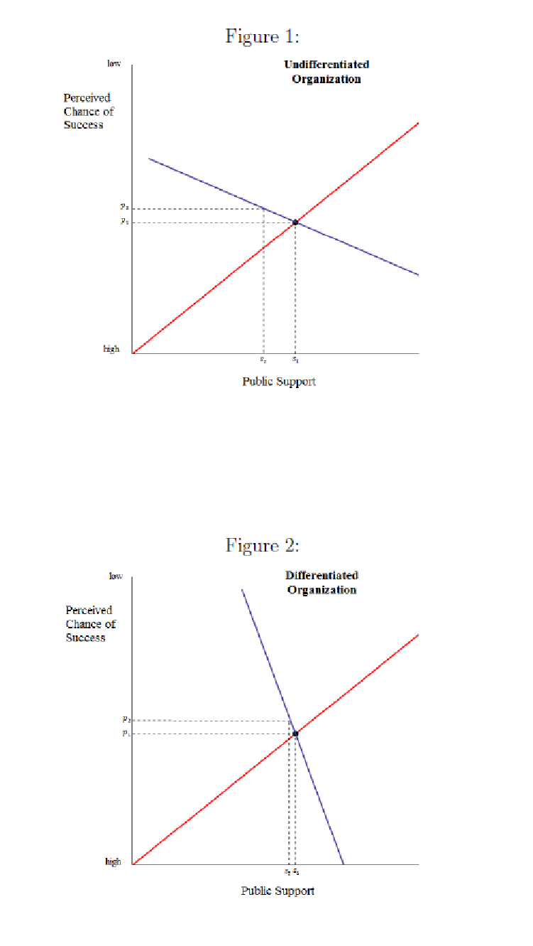
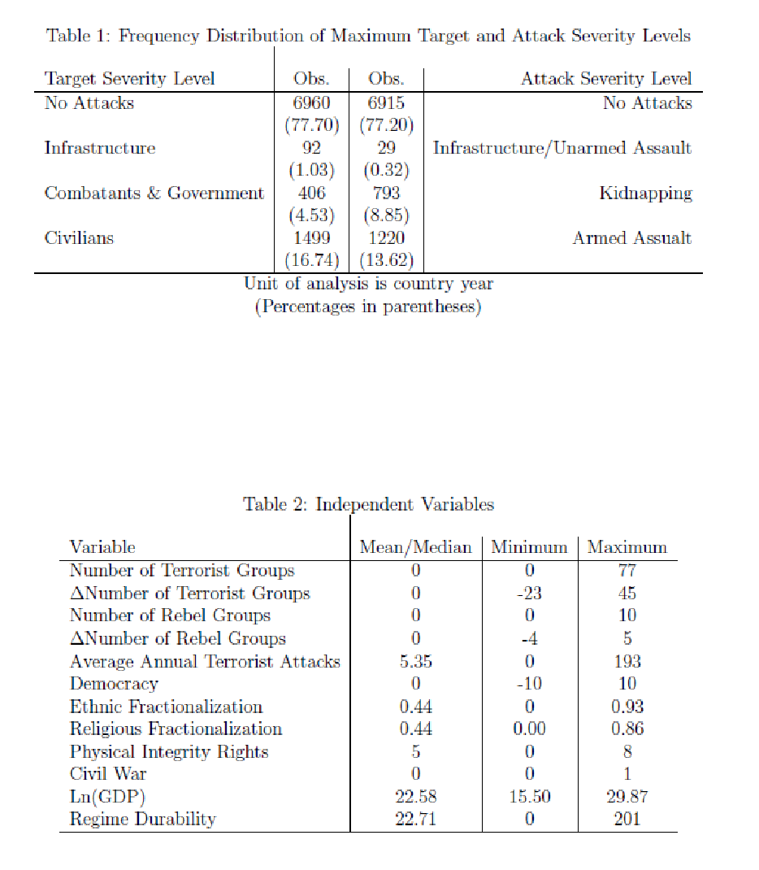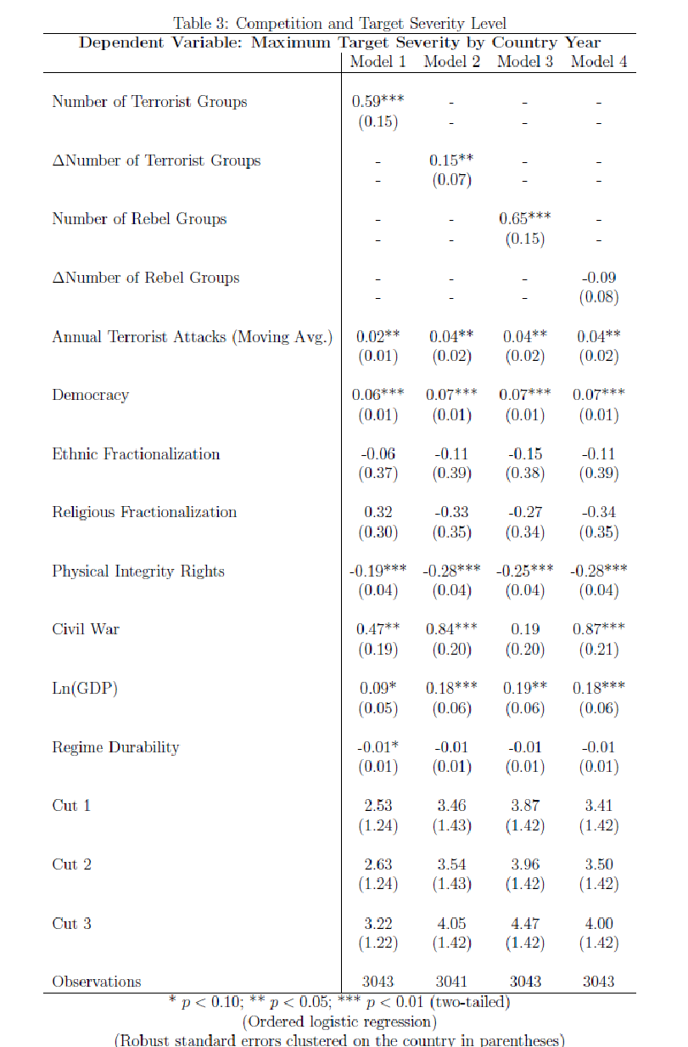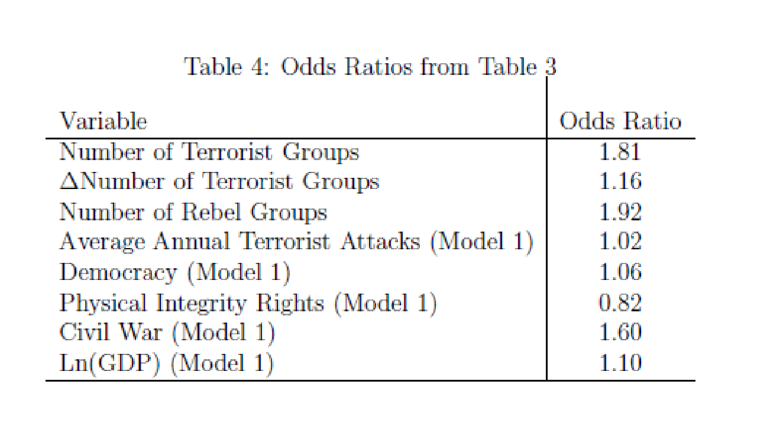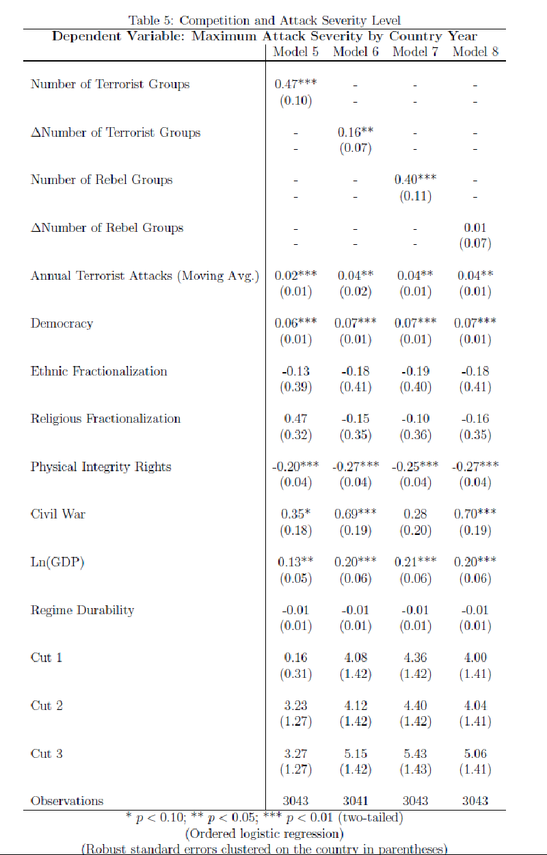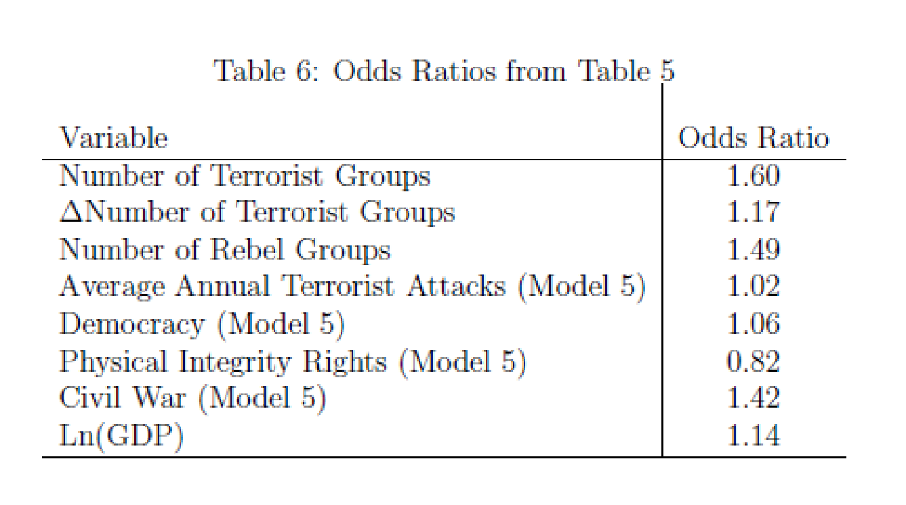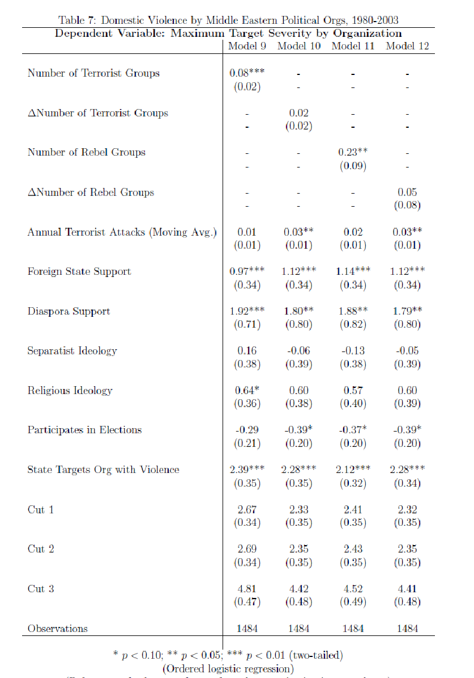

“Bin Laden’s Last Stand,” Washing Post, April 30, 2012: http://articles.washingtonpost.com/2012-04-30/world/35452658_1_qaeda-osama-bin-laden
Throughout the study we use terms such as “severity,” “more extreme” and “shock value” interchangeably. The concept which we are capturing, however, is the same: some attacks have greater psychological impacts, garner greater media coverage, and are likely to influence a wider audience than others.
The tactic of suicide terrorism was not innovative within Israel and the Palestinian territories per se. It was arguably pioneered by Hezbollah in Lebanon some 10 years earlier, but the First Intifada in Israel marks the beginning of its widespread use in the Israeli-Palestinian conflict.
More violent organizations are also likely to attract more violent and zealous recruits (e.g., Chai 1993). Either way, the organization is likely to recruit individuals that are less sensitive to the overall success of the organization.
The logic behind this “outbidding” process assumes rationality, even though the rationality of suicide terrorists has been heavily debated.. There seems to be general agreement, however, that terrorist organizations, if not the individual terrorists, use suicide terrorism in an economically rational manner (Caplan 2006, p. 94). The use of suicide terrorism offers a number of potential gains for a terrorist organization while the most substantial costs are paid primarily by the individual terrorists, rather than the leaders of the organization or the organization itself.
Bloom (2005) also discusses a similar logic behind the use of suicide terrorism in Sri Lanka and Turkey.
Of course, increasing the severity of violence is not the only choice for organizations. Bapat and Bond (2012), for instance, find that some terrorist organizations respond to competition by forming alliances.
Nemeth argues that a higher number of terrorist organizations creates incentives for organizations to free ride on the violence committed by others, leading to a decrease in the overall amount of violence.
Two other miscellaneous categories were coded as missing, “religious” and “abortion,” because the categorization of these two was less straightforward. However, in robustness checks, we included both target types in the highest severity level (‘3’) and the conclusions that we draw are unchanged. In general, while some classifications in our scale are certainly open to debate, it seems that the overall order and grouping are accurately capturing a single latent variable, something that is supported by the statistical significance of the cutpoints in each model below.
As with the target severity variable, we developed alternative coding schemes for robustness purposes. We also analyzed our models using a two category version, coded as ‘1’ for attacks in which violence against humans is not the primary goal (infrastructure attacks, hijackings, hostage takings and unarmed assaults) and ‘2’ for attacks where violence against humans is central to the attack (assassination, armed assaults and bombings). The results using this consolidated variable are comparable to those reported in the paper.
To be considered active in a given year, the rebel groups must be associated with at least 25 battle deaths during that time.
In Table 5, the cutpoints are all statistically significant different from each, once again indicating that the each of the categories in the dependent variable is tapping into a distinct level of violence.
Nemeth creates an index based on the state’s level of political terror, use of capital punishment and involvement in interstate and intrastate conflicts.

